St Kieran’s College

Secondary School,

Kilkenny

Wellbeing Plan 2023/2024

**Index**

**Wellbeing Plan Rationale**3

**Curricular provision**3

**Planning for Wellbeing Using Planning Principles and Steps**4

**Promoting Wellbeing**5

**Wellbeing indicators**6

**Aims & Objectives**6

**Whole School aims**6

**Wellbeing Team & Induction of New Teachers**7

**Time Allocation and Timetabling**7

**Planning for Students with Additional Extra Needs (AEN)**9

**Whole School Wellbeing**10

**Promoting Wellbeing skills in our students**10

**Teaching Strategies and Methodologies**11

**Assessing Wellbeing**12

**Record Keeping Procedures**13

**Teacher Professional Development**13

**Targets for Next Year**13

**Appendices** **Error! Bookmark not defined.**

## School Mission Statement

## St Kieran’s College, as Ireland's oldest all-boys Catholic Secondary School, continues its founding aim of the pursuit of real excellence in education and formation, in the light of the Gospel, so as to allow all our students to realise the fullness of their potential.

## Academically, spiritually, physically and emotionally our students are encouraged to strive for all that is possible in the relentless pursuit of perfecting their individual gifts and talents.

## In so doing they bring to life the joy intended by our motto, “Hiems Transiit”, for themselves, those they love and the community where they will live, serve and lead.

## Wellbeing Plan Rationale

This document was prepared by the Wellbeing Committee on behalf of, and in consultation with, St. Kieran’s College Staff, Students, Parents and Board of Management. This plan has been developed to ensure that our school adequately responds to the changing and diverse needs of each of our pupils and is complemented by the schools Wellbeing Policy/ Statement.

The Framework for Junior Cycle (2015) provides for a new era of learning at Junior Cycle called Wellbeing. The updated Wellbeing Guidelines 2021 guidelines aim to support schools in planning and developing a coherent Wellbeing programme that builds on the understandings, practices and curricula for wellbeing already established in schools.

The disruption of normal school life brought about by Covid-19 has heightened awareness about the importance of wellbeing for all members of the school community. Wellbeing will cross the three years of Junior Cycle and build on substantial work already taking place in our school in support of students’ wellbeing.

This area of learning will make the school’s culture and ethos and commitment to wellbeing visible to students. It will include learning opportunities to enhance the physical, mental, emotional and social wellbeing of students. It will also enable students to build life skills and develop a strong sense of connectedness to their school and their community.

## Curricular provision

* From September 2021/22 wellbeing will require a minimum of 400 hours timetabled engagement.
* For 1st years entering post-primary school from September 2022, the minimum allocation for PE, CSPE and SPHE is set out as follows:

**PE:** 135 hours spread out across first, second and third year.

**CSPE:** 100 hours spread out across first, second and third year.

**SPHE:** 100 hours spread out across first, second and third year.

**Other Units of Learning/ Short Courses:** 65 plus hours spread out across first, second and third year.

* From September 2022 onwards, the use of the Junior Cyce syllabuses for SPHE and CSPE should be discontinued and schools are advised to adopt the NCCA short courses in SPHE and CSPE. These short courses have been developed to provide meaningful learning and also include assessment guidance both for ongoing and summative assessment.
* All subject planning will include Wellbeing and teachers should embed wellbeing into their curriculum and ensure it is visible to students.
* Wellbeing will be further embedded into the school curriculum through three key subject areas which are; CSPE, SPHE, PE and Other Units of Learning/ Short Courses that the school will implement.

**Provision for Wellbeing will draw on the 4 different aspects of wellbeing that can be seen below:**

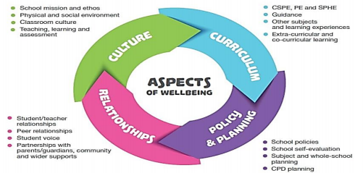

At St Kieran’s College, the Wellbeing of our school community is paramount. Our environment of care and support is both formal and informal. The Wellbeing Policy aims to make visible our ongoing efforts to enhance student Wellbeing. It aims to outline our curricular offerings which have at its core student Wellbeing.

Moreover, it aims to outline our informal support which allows a holistic approach to enhancing our school communities' well-being, in accordance with our mission statement.

## Planning for Wellbeing Using Planning Principles and Steps

**6 Planning Principles**

When planning for wellbeing the following are considered thoroughly by all wellbeing committee members:

* A collaborative approach
* A consultative approach
* Flexibility to respond to students’ needs
* Mapping of local community resources
* Adapting to change and to new and emerging circumstances
* Linking planning for junior cycle Wellbeing with the school’s SSE process

**5 Steps for Planning Wellbeing**

St. Kieran’s College have formed a Wellbeing team to oversee the planning and evolution of a meaningful and coherent Wellbeing programme. The Wellbeing Team comprises members of staff who developed and coordinated a Wellbeing class for the school junior cycle. The team was comprised of a Deputy Principal, one Guidance Counsellor, PE, CSPE, SPHE, SEN teachers, Chaplain and a member of the Digital Learning Committee.

The steps involved in this process are shown below and these should not be seen as once-off but on-going in nature.

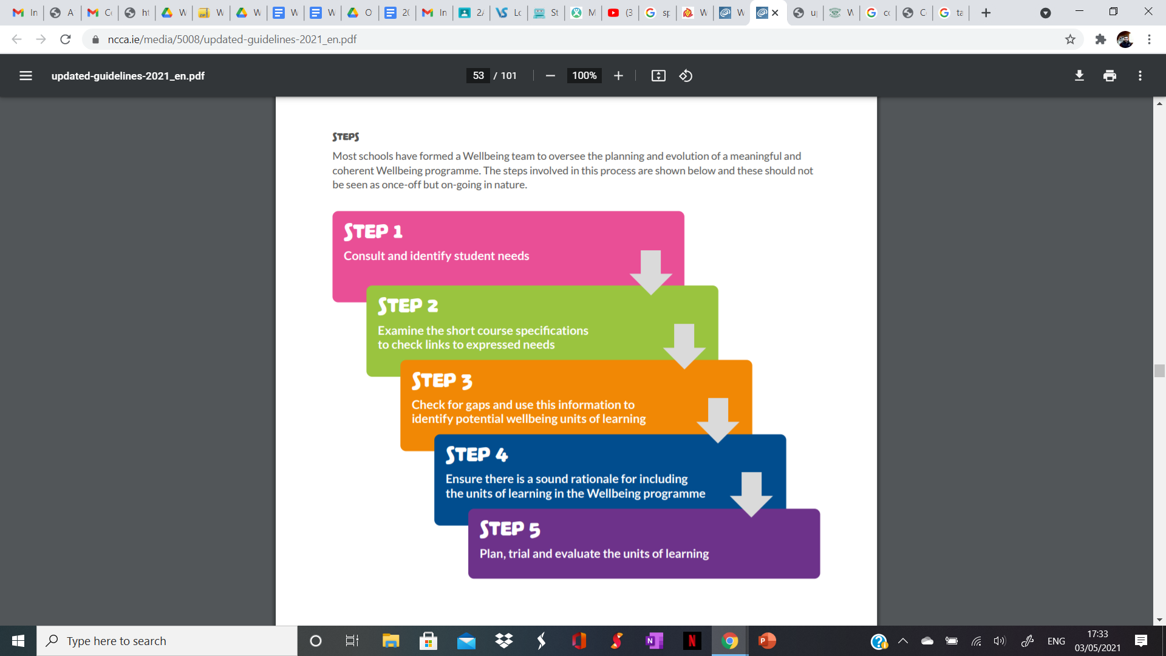

## Promoting Wellbeing

St Kieran’s College recognises the importance of developing the whole person; emotionally, mentally, spiritually and physically and we provide a range of supports and interventions that address these aspects. These include:

* Organising and implementing Mental Health activities throughout the school year, especially during ‘Mental Health Week’..

• The co-ordinated implementation of our Whole-School Guidance Plan.

• Building positive interpersonal relationships.

• Ensuring that our students are aware of the range of supports within the school as well

as those offered by external agencies.

• Providing opportunities to develop their physical well-being through physical

education and extracurricular activities.

• The effective and consistent implementation of SPHE, CSPE and P.E as part of a whole-school

approach to the promotion of wellbeing in our students.

• Addressing the spiritual needs of students through religion class, liturgical celebration

and prayer.

• Implementation of the whole school approach to SEN

## Wellbeing indicators

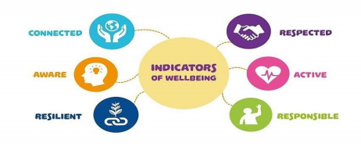

We have designed a wellbeing programme that is flexible and suits our students and our local context.

In designing our wellbeing programme we have ensured that all of the Six Wellbeing Indicators - Active, Responsible, Connected, Resilient, Respected and Aware have been identified in our programme and are central to it’s provision and delivery.

These indicators make explicit what is important for teachers, parents and the wider school community.

## Aims & Objectives

The goal of our policy/ plan document:

Aims

* All staff contribute to promoting a caring and inclusive environment within the school that is supportive of school wellbeing.
* To provide for the wellbeing of all students in the school in the light of the school Mission Statement.
* To provide for the wellbeing of all students in the school in the light of the effects that Covid-19 restrictions has had on some students.
* Recognise the relationship between positive experiences of school life, student achievement and long-term wellbeing.
* To enable students to develop personal and social skills.
* To promote self-esteem and self-confidence.
* To promote physical, mental and emotional health and well-being.
* To provide opportunities for reflection and discussion.
* To enable students to develop a framework for responsible decision-making.

Objectives

* Students will develop invaluable skills such as open-mindedness and independent thinking by in- class debates and discussions and role play.
* Students will get the opportunity to develop personal and social skills and an understanding of the importance of physical, mental and emotional health and well-being.

## Whole School aims

* Developing and implementing policies and procedures to support student wellbeing Ensuring student wellbeing is central to teaching practices and student learning
* Raising awareness in the school community of issues related to student wellbeing

## Wellbeing Team & Induction of New Teachers

Core Team:

Jennie Brennan, Fergal Brennan (Chaplain), Sean Morrissey, Brian Dowling, Evan Walsh & Liam Smith.

In order to support the 400 hours minimum timetabled wellbeing curriculum teachers of Junior Cycle P.E, SPHE, CSPE and teachers that will administer Units of Learning will be considered as teachers that will support our wellbeing programme.

These teachers are as follows:

P.E - Tom Brennan, Michael Walsh, Ken Archbold & David McCormack.

SPHE - Fergal Brennan, Sean Morrissey, Jennie Brennan

CSPE - Sean Morrissey, Michael Connolly, Jennie Brennan, Ben Tomkins.

1st year Wellbeing - Fergal Brennan

1st year Form - Fergal Brennan, Hollie Hickey, Sean Morrissey, Evan Walsh.

Units of Learning

Fergal Brennan, Evan Walsh, Sean Morrissey, JonJo Farrell.

**Induction of New Teachers**

Teachers involved in the schools Wellbeing Programme should facilitate new teachers as much as possible in the following ways:

* Access to information regarding new SPHE & CSPE short courses.
* Given access to the SPHE, CSPE, P.E Department folders.
* A copy of each Subject Plan/ outline to be handed over/ discussed/ shown.
* A set of books to be given/ available to use if applicable..
* Given information on in-service training available, where the local training centre is and the process involved in accessing such training.

Explain simple details of :

* Where to get board markers, duster etc.
* How to access the computer room for research/ web-based classes
* Resources and resource-sharing
* Curriculum and its implementation for each year group
* How to use any necessary equipment in the relevant classrooms.

## Time Allocation and Timetabling

The Wellbeing Programme in St Kieran’s College has allocated **over 400 hours for Wellbeing** in Junior Cycle.

The Junior Cycle wellbeing guidelines place a strong emphasis on the role that CSPE, SPHE, PE and Guidance can play in supporting learning about Wellbeing and learning for Wellbeing. The Form Class, which incorporates Guidance will follow a structured plan for the academic year. The Wellbeing Indicators that we have identified in the plans for both of these classes include: *Responsible, Connected, Resilience, Respected and Aware*.

* Each single class is 1 hour in duration

In total there are 367 hours of Wellbeing visible in our timetable for P.E, SPHE, CSPE and Form Class (1st yr only):

|  |  |  |  |  |
| --- | --- | --- | --- | --- |
|  | **1st Year** | **2nd Year** | **3rd Year** | **Total Hours** |
| **PE** | Double Class | Single Class | Single Class | 136 |
| **SPHE & RSE** | Single Class | Single Class | Single Class | 99 |
| **CSPE** | Single Class | Single Class | Single Class | 99 |
| **Form Class** | Single Class |  |  | 33 |
| **Total** |  |  |  | **367 Hours** |

**Wellbeing in Other Areas**

The table below outlines the other experiences and areas of learning over the course of the Junior Cycle that we have identified where student Wellbeing is central and which of the Wellbeing Indicators are identified in each area.

In total there are another 97 hours of experiences and learning where Wellbeing is visible outside the normal timetabled hours at Junior Cycle.

|  |  |  |  |  |
| --- | --- | --- | --- | --- |
|  | **1st Year** | **2nd Year** | **3rd Year** | **Total Hours** |
| **Retreats** | Full Day | Full Day | Full Day | 18 |
| **History Trip** | Full Day | Full Day | Full Day | 18 |
| **St Kieran’s Day** | Half Day (morning) | Half Day (morning) | Half Day (morning) | 12 |
| **Sports Day** | Half Day (morning) | Half Day (morning) | Half Day (morning) | 12 |
| **Blitzs x 2** | Full Day x 2 |  |  | 12 |
| **Cairdeas** | 10 classes |  |  | 7 |
| **Mental Health week - Speakers and Activities** | Mental Health Activity | Mental Health Activity | Elma Walsh talk | 5 |
| **Speakers** | Guest x3 | Guest x3 | Guest x3 | 9 |
| **Induction Day** | Morning |  |  | 2 |
| **Michael**  **Brannigan memorial fun run** | Afternoon |  |  | 2 |
|  |  |  |  | **97 Hours** |

**Total Wellbeing Hours Allocated: (367 + 97) = 464 hours.**

The Wellbeing Indicators that we have identified in these other areas are as follows:

|  |  |  |  |  |  |
| --- | --- | --- | --- | --- | --- |
| **Retreats** | Responsible | Connected | Resilience | Respected | Aware |
| **History Trip** | Connected | Aware | Respected |  |  |
| **St Kieran’s**  **Day** | Active | Connected | Respected | Aware |  |
| **Sports Day** | Active | Connected | Respected |  |  |
| **Blitzs/Run** | Active | Connected | Respected |  |  |
| **Cairdeas** | Responsible | Connected | Resilience | Respected | Aware |
| **Guest**  **Speakers** | Responsible | Connected | Resilience | Respected | Aware |
| **Induction Day** | Responsible | Connected | Resilience | Respected | Aware |

## Planning for Students with Additional Extra Needs (AEN)

Using the NEPS continuum of provision as a framework - “*Wellbeing in Post-Primary schools*”, this document provides an overview of the provision in the school in relation to promoting and supporting the wellbeing of all students. Please see the schools SEN policy for more details.

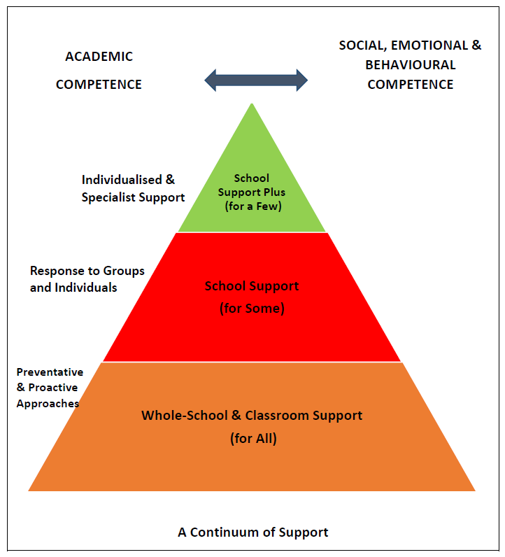

* 
* **Managing Sensitive Issues**
* Wellbeing teachers to liaise with the Pastoral Care team (Ken Maher, Liam Smith, Eadaoin Maher, Brian Dowling and Fergal Brennan) with regard to sensitive issues that may be dealt with in class.
* All wellbeing staff must be familiar with the school’s policies that relate to sensitive issues that may emerge in any wellbeing class, e.g. child protection, RSE, substance use, etc.
* Every effort should be made to safeguard the privacy of students and teachers. This can be addressed in the ground rules.
* Allow time at the end of class for summing up learning. If an issue arises during class that needs attention before the group breaks up for the next class, it can be dealt with at this time.
* Teachers should not give unconditional guarantees of confidentiality. It should be explained to students that, in some circumstances, the teacher may need to seek advice or to tell someone about an issue raised in class.
* For some topics, you may need to consider the following question: Is there anyone I need to be particularly sensitive and aware of because of their disposition or recent experience?
* Advise students that any wellbeing class is not a suitable forum for disclosing sensitive issues of a personal nature. Students should be advised about where they can go for help.
* If an unexpected disclosure is made that causes concern it should be referred as appropriate (informed by school policy) to the DLP or DDLP.

## Whole School Wellbeing

Staff at St. Kieran’s College work in a supported environment.

Whole school wellbeing is evident in the following areas:

* Admissions Policy.
* Anti-Bullying Policy.
* Children First Act 2015.
* Counselling Policy.
* Child Protection Procedures for Primary and Post Primary Schools 2017.
* Child Protection Procedures for Primary and Post-Primary Schools (revised 2023)
* Child Safeguarding Statement and Risk Assessment.
* Code of Behaviour.
* Critical Incident Policy.
* CSPE Plan
* GDPR Policy.
* Whole School Guidance Plan
* Healthy Eating Policy.
* PE Plan.
* Remote Learning and Teaching Policy.
* RSE Policy.
* School Plan.
* SEN Policy.
* SPHE Plan

## Promoting Wellbeing skills in our students

**First Year:**

SENCO and SEN teachers liaise with parents of students with identified learning needs to allow us to identify, plan for and respond to needs in a flexible way.

* All first years participate in a 1 day Induction programme to help them make the adjustment from primary to secondary school.
* Each 1st year class has 1 form class per week with their assigned Form Tutor.
* Our 10 week Cairdeas Programme helps 1st yr students adjust to secondary school. Each 5th year Cairdeas leader is assigned to a group of 5 1st year students and acts as a ‘big brother’ to assist them with any queries they may have.
* Michael Brannigan Memorial Run is a fun day for 1st year students only.
* Annual Sports Day encourages 1st year students to take up a new sport and become engaged in extracurricular activities.
* Literacy Intervention - Vocabulary Enrichment Program is delivered to support development of oral and written vocabulary to build skills and confidence.
* Numeracy Intervention - Numeracy supports.

**First to Third Year.**

* A comprehensive S.P.H.E. (Social, Personal & Health Education) programme, delivered 1 hour long class per week, provides valuable insights and information to students.
* All Junior Cycle classes have 1 hour of CSPE class per week promoting active citizenship.
* All junior classes have at least 1 hour of PE per week (First Years have 2 hours). PE provides students with the opportunity to choose a lifestyle that is active, healthy and meaningful, in order to contribute to the preparation of the student for a life of wellbeing.
* Mental Health Week – inclusive week. Mental health activities for 1st and 2nd years and guest speaker for 3rd years.
* The guidance department delivers a ‘subject choice’ module to 3rd year students which includes classroom contact and subject choice assemblies.
* Transition Year, senior cycle information night for parents and guardians every March for 3rd year students and parents/guardians.
* All junior classes go on a Retreat to various locations.
* All junior classes participate in ‘St Kieran’s Day’ - a fun day in the school that celebrates the school's patron St Kieran on the 5th of March (closest day to feast day).

**First to Sixth Year.**

* Year Heads monitor an entire year group in conjunction with the Chaplain, Guidance Counsellors, SEN Teachers, Deputy Principals and Principal.
* Regular assemblies are held in each group.
* There is a Chaplain and two career guidance counsellors to help students who may encounter difficulties during the school year.
* The school Chaplain works closely with the staff as we try to respond to students’ needs, and has a specific responsibility for their spiritual and pastoral development.
* Various PE initiatives for senior students, to encourage lifelong physical activity.
* Throughout the school year significant religious events are celebrated.
* Liturgies occur at relevant times and a school mass celebrates the beginning of each school year.

## Teaching Strategies and Methodologies

**SPHE & CSPE:**

Discussion

Discussion has a key role in SPHE and CSPE. It provides a chance for students to talk about their ideas and feelings and can open up opportunities for developing or changing their ideas or feelings where appropriate.

Ground rules for discussion in SPHE & CSPE are as follows:

* everyone is shown respect
* everyone is given a chance to speak in the group
* everyone is listened to, no interruptions
* no put-downs
* everyone's right to their opinion is respected
* everyone is expected to back up their opinion with an examples or evidence from the stimulus
* everyone has the freedom to change their opinion based on reflective discussion
* there should be no generalisations.

Role Play

It is important to choose a theme that is clearly focused and is likely to generate worthwhile reflection, analysis and debate. Allowing sufficient time to bring students out of role and to discuss their experience of role-play is also vital. Students who would prefer not to participate in a role-play can play an important role in actively listening and reporting on what they have observed.

Guest speakers

Guest speakers will be invited in to complement particular key concepts as the need and opportunity arises.

#### Debate

A debate works best if students are given a chance to debate a topic that is of genuine interest to them and if they are given time and support to prepare for the debate (background information, newspaper/magazine articles, useful websites, etc).

A Walking Debate

A `**walking debate'** is another good way of allowing students to debate an issue. In this method, a statement is read out to the class and they are asked to position themselves at one end of the class-room if they agree with the statement and at the other end if they disagree. Those who are uncertain can stand in the middle. As the issue is debated, students can move their position. The movement encourages opinions to change and also allows for uncertainty and an acceptance that all issues are not black and white.

#### 

#### Issue Tracking

Issue tracking is a method by which students can follow and explore an issue or topic that is currently in the news. Issue tracking develops group work and cooperation skills, as students must work in groups and decide on the best way to collect information. The teacher can stimulate the search by bringing newspapers to class on the first day or by showing a news report on the chosen issue. Students can compile a scrapbook or wall chart, or use the internet and computer to compile an electronic scrap-book. This methodology allows for discussion on the difference between fact and opinion and the role of perspective and bias in the media.

Photographs, Art Work and Images

An image or photograph can be a useful way of stimulating interest in a topic, especially if the image is slightly puzzling or challenging. Students can be invited to question the photograph. Who took it? Where was it taken? What was happening at the time the photograph was taken? What happened next?, etc. It is important to avoid using images that may reinforce students' prejudices or stereotypes.

#### 

#### Surveys / Questionnaires

A survey or questionnaire can develop skills of communication, gathering and interpreting information, team work and cooperation. It enables action beyond the classroom and can often involve the school or wider community. Careful attention needs to be given to discussing the purpose of the survey, what it hopes to find out and how the findings will be shared with others.

#### Working with Texts

Short stories and texts from newspapers, magazines and the Internet can be a very useful way of presenting information and issues related to Wellbeing. There are many ways that students can engage with texts in an active manner.

Other Methodologies

Individual Reflection / Think, Pair, Share / Group Work / Use of AV media (C.D, data projector) / Teacher Exposition / Internet resources, Google Classroom.

## Assessing Wellbeing

The Framework for Junior Cycle states that all assessment in junior cycle should have as its primary purpose the support of student learning.

Assessing students will be done collaboratively among wellbeing teachers.

Students can be asked to complete assignments, project work, presentations, performances, engage in self/peer assessment, reflect on their learning and set goals for the next steps in learning. Teachers can also use effective questioning and dialogue to allow students to make their learning visible and to plan for improvement. All assessment activities will be effectively carried out and supported by success criteria stating what a good piece of work looks like in the contexts involved. Please see Appendix 1 for document on Wellbeing staff collaboration.

## Record Keeping Procedures

Class and homework monitored each week.

Attendance recorded in teacher’s journal and on TYRO system.

## Teacher Professional Development

In-service and CPD to continue for department members.

CPD already undertaken:

**SPHE:**

**SPHE online workshops April 2021:** Fergal Brennan & Michael Connolly.

**2 day Intro to SPHE:** Michael Connolly, Jonjo Farrell, Brian Dowling

**RSE Junior Cycle** :Evan Walsh, Sean Morrissey

**Anti Bullying**: Brian Dowling and Fergal Brennan

**Substance Abuse:** Jonjo Farrell

**Intro to Mental Health**: Fergal Brennan

**RSE Senior Cycle (Nov 2018):** Fergal Brennan, Jonjo Farrell

**NEPS Friends Programme(Oct 19,2019):** Michael Connolly

## 

## Appendices

